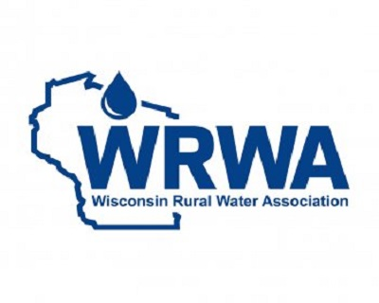
Wastewater Operations: Sanitary Sewage Collection System
September 7, 2022
Readstown Municipal Building
116 N 4th Street, Readstown, WI 54652
(6 Wastewater Credits)

The room will open at 7:30 AM with the class starting promptly at 8:00 am. The class will end at 3:00 pm.

8:00 am – 8:30 am: Terminology
8:30 am – 9:15 am: Safety
9:15 am – 10:00 am: Collection System Components
10:00 am – 11:00 am: Operation and Maintenance
11:00 am – 12:00 pm: Lunch (on your own)
12:00 pm – 1:00 pm: Rehabilitation and Records Retention
1:00 pm – 2:00 pm: Ordinances and Regulations
2:00 pm – 3:00 pm: Calculations

Instructor: Tony Roche – Wisconsin Rural Water Association
Complete the form below and return to WISCONSIN RURAL WATER ASSOCIATION
______September 7, 2022
Member Fee $100.00________ Non-Member Fee $125.00___________
Name __________________________________________________________________________
System/Employer _________________________________________________________________
Address_________________________________________________________________________
City, State _______________________________________Zip _____________________________
Phone_____________________________Email_________________________________________
Send payment and form to: WRWA, 350 Water Way, Plover, WI 54467

To pay by credit card: (Visa, Discover, MasterCard, Debit Card Only)

Go to www.wrwa.org - Must fax completed form(s) to (715) 344-5555 or email the completed form(s) to wrwa@wrwa.org.

Check enclosed Paid with credit card

For more information: Phone: (715) 344-7778 Email: wrwa@wrwa.org

